NodeJS famous and popular server technology that let us write server code in javascript.

It's designed to be able to use JavaScript to write server code.

Don’t Imitate , Uderstand !

CLI – Command Line Interface

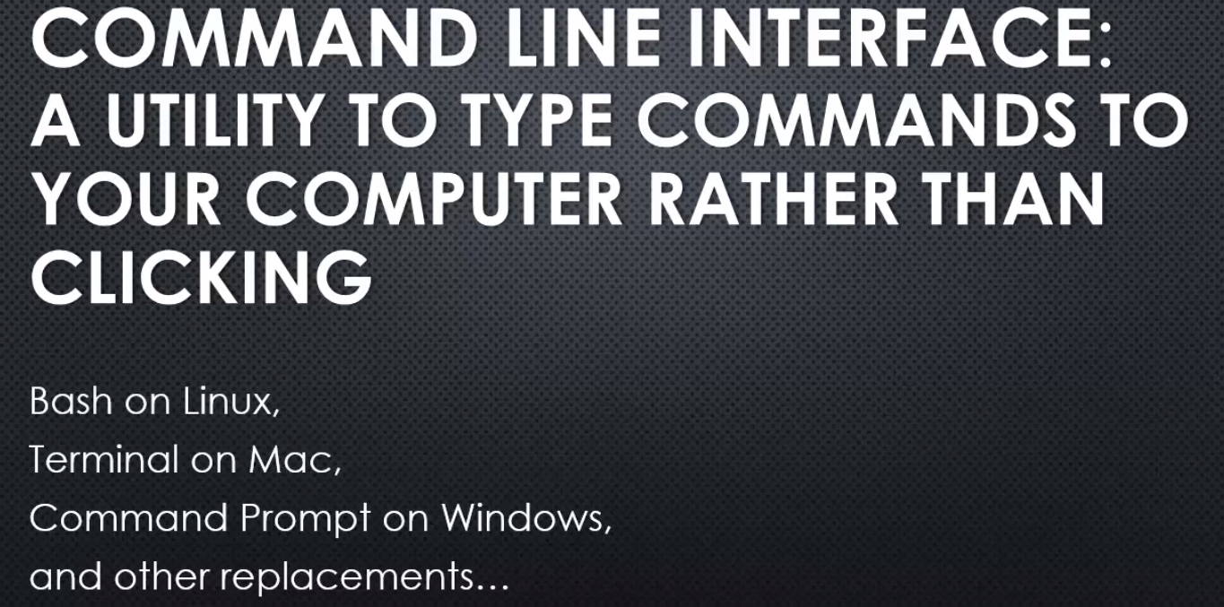

You type in a command,you type in programs that you want to run, and they run. Rather than clicking around with your mouse. And actually this is the way that things used to be. Computers didn't always have graphical user interfaces or GUIs,

Now sometimes the command line interface will

provide commands that help a little bit visually.

For example I can put dir /w.

That is an argument.

Arguments are values you give your programme

that affect how it runs.

Essentially this is like passing a value

to a function if your programming.

Your programme, the name of your programme is what you type

or the name of your command is what you type.

And then after that, separated by spaces most often,

you type different arguments that

that particular command or particular programme expects.

And you just have to know again what they are.

But the argument will then affect what the programme does.

The programme might say if you give me this argument,

I'll behave this way or a different argument

and I'll behave a different way.

Using the command line interface

is about knowing the commands, knowing the programme,

and all of the arguments that it takes.

And then how you can string those commands

and arguments together to do what you want.

Using Node.js,

really using many of the ways

that we build modern web software now,

means knowing how to use the command line interface

and knowing certain commands.

The thing at the heart of Node JS.

The V8 Javascript engine.

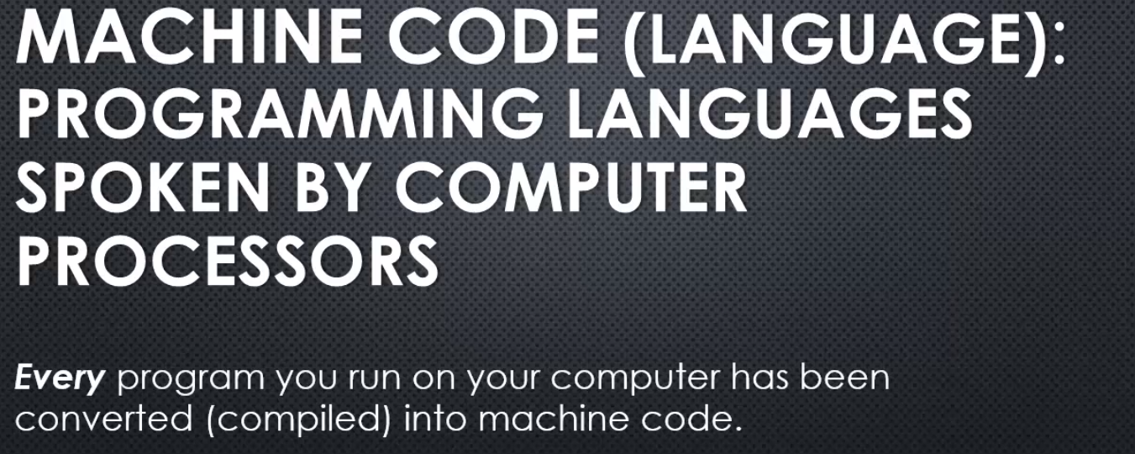

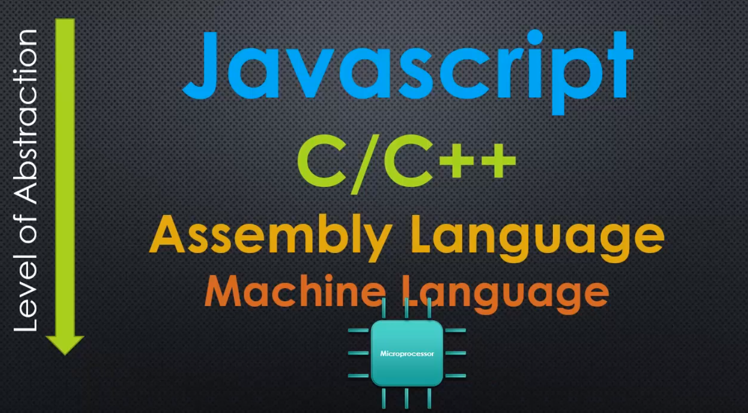

There have been levels of abstraction added to us,

that get us to this modern era of computer programming.

So there's things like assembly language that came later.

That is still pretty close to machine language

but a bit easier to understand and read.

And then there a huge era of C and C++

and that really took off.

C and C++ is still used heavily today

but it's syntax, if you see,

it looks a bit more like Javascript or Java.

Because Java and Javascript were inspired by what's called,

C syntax that is the way C and C++ programmes look

when they're written.

Things like curly braces and functions

but C and C++ still lets you have

a degree of control that's lower-level.

And so a bit closer to the microprocessor itself.

And that's why it's very popular to use,

because you have a great degree of control

but it's easier to code in

than assembly or machine language.

And then you have programming languages,

very high-level programming languages like Javascript,

which are very far removed from the computer's processor.

We don't deal directly with where memory is

and what it's doing.

You have an engine between you and the microprocessor

that's taking care of all those things for you.

So when we're talking about writing Javascript

we're really talking about writing a programming language

that some other programmes are going to convert

into something like machine language.

And that's not to say that you have to go down this tree

that Javascript becomes C or becomes assembly

or anything like that.

You can jump around.

Perhaps Javascript gets converted directly

to machine language, but nonetheless,

something is going to do that work.

So we sit very high in these levels of abstraction

as modern developers in web development.

We sit very far away from the microprocessor.

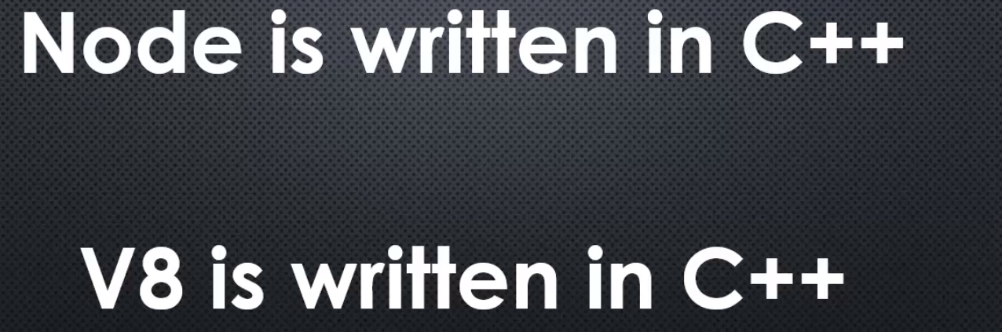

Node is written in C++.

Now you might be thinking, "whoa, wait a minute,

everything I see about Node

and when I'm trying to learn Node JS, is about Javascript.

When I'm writing Node, I'm writing Javascript."

Well that's true, you're writing in Javascript.

We write in Javascript when we write Node programmes

but Node itself, is written in C++,

it's a C++ programme.

And the reason why Node is a C++ programme,

is written in that programming language,

is because V8 the Javascript engine is written in C++.

V8 the thing that converts Javascript to machine code,

is written in C++.

And so Node, which adds onto it, is also written in C++

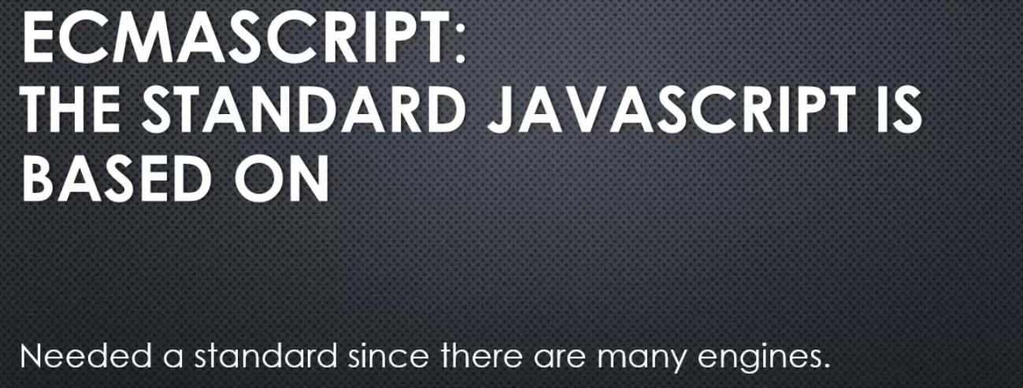

we are going to talk about some

JavaScript concept, some part of the language itself

that will move on to helping us understand Node.js.

This JavaScript aside is JavaScript Engines

and the ECMAScript Specification.

Oh, and just to avoid any confusion,

big word alert: ECMAScript.

ECMAScript is the standard that JavaScript is based on.

JavaScript was invented first,

but then different browser makers, like Microsoft, Netscape,

they started making their own JavaScript engines

and their own little tweaks, and changes,

and differences between them.

And the ECMA is an organisation that basically

is a standard organisation that says,

"Hey, let's try and say exactly how something should work."

And so ECMAScript is the name for the core standard

that JavaScript itself bases itself on.

And we needed that standard because

there are many engines out there.

V8, which Node.js is built on top of,

is actually just one of many JavaScript engines.

So, when we are talking about JavaScript

and we are talking about ECMAScript,

you can basically think of them as the same thing,

but JavaScript is the actual language that we are writing,

and ECMAScript is the standard that says

how the language should work,

it's a core scripting language standard.

All right, but for the purposes of our discussion

they are essentially interchangeable terms.

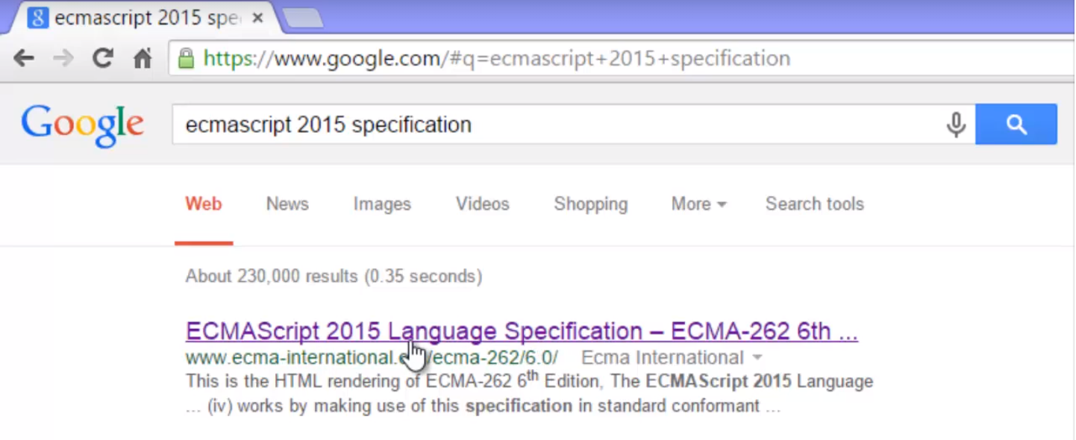

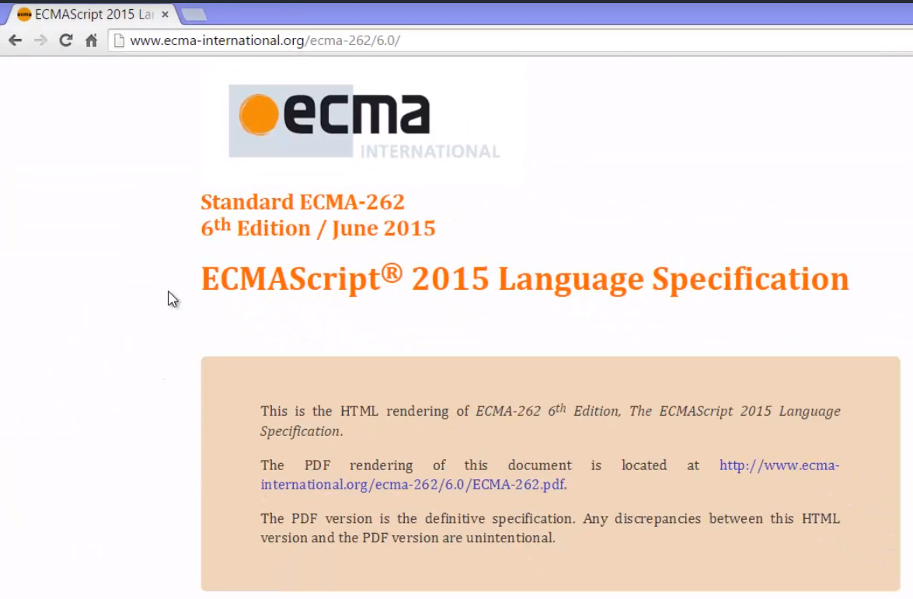

If you look at the specification

and were to go down through it,

you'd see all sorts of things that JavaScript

is supposed to have and supposed to do.

It describes its behaviour,

it describes exactly what should be expected

when certain things are done in the language,

and therefore is the standard upon which

JavaScript engines should be based.

In other words, if you were to write

your own JavaScript engine,

what you cause JavaScript code to do

should match the specification.

V8 does that.

V8 makes sure that the JavaScript code that is written,

the machine code that it's translated to does

what the specification expects it to do.

And the specification is just a standard

that everyone has agreed upon,

this is the way JavaScript should work

Java script Engine - 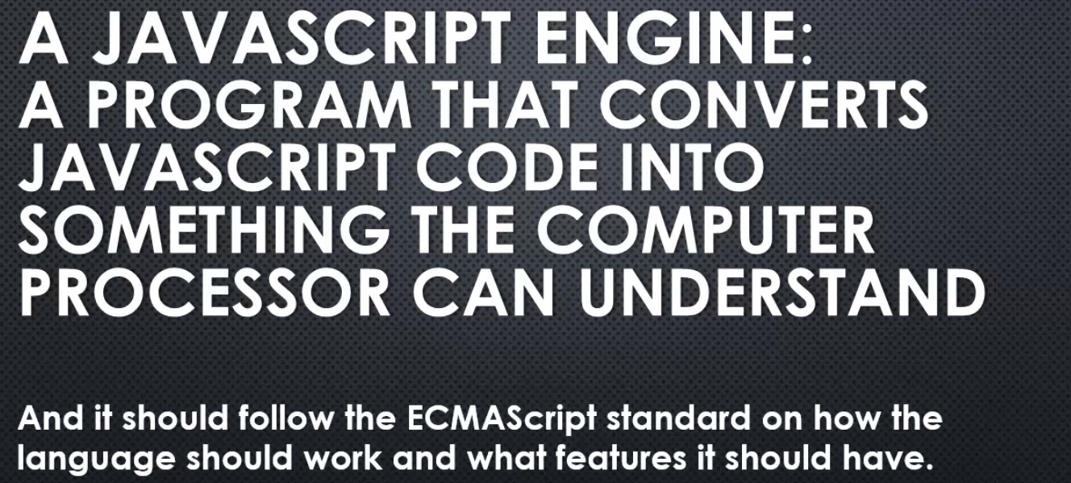

**V8 is a JavaScript engine, and it sits at the core of Node.js.**

**V8(JavaScript engine)-** Google's V8 engine is open source.

It's available to look at, to use, and to even change

for your own purposes.

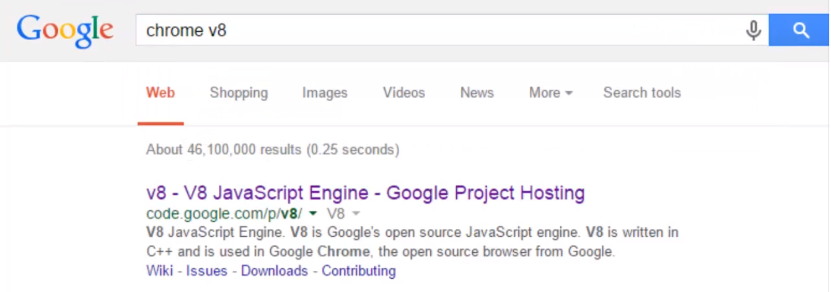

I searched for Chrome V8 because V8

was primarily written to be used inside the Google Chrome

browser, and it certainly is.

However, it's also built in a way that let's it be used

elsewhere, and in other ways.

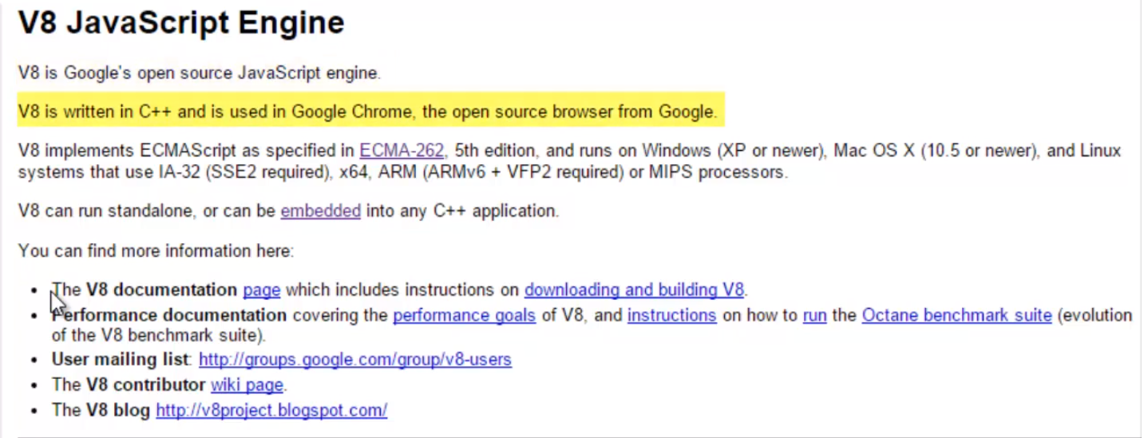

go to source and then click the link,

there's a Git repository, a source code repository,

that is to say, there's a spot where all the source code

of V8 lives, and I can go grab it free of charge.

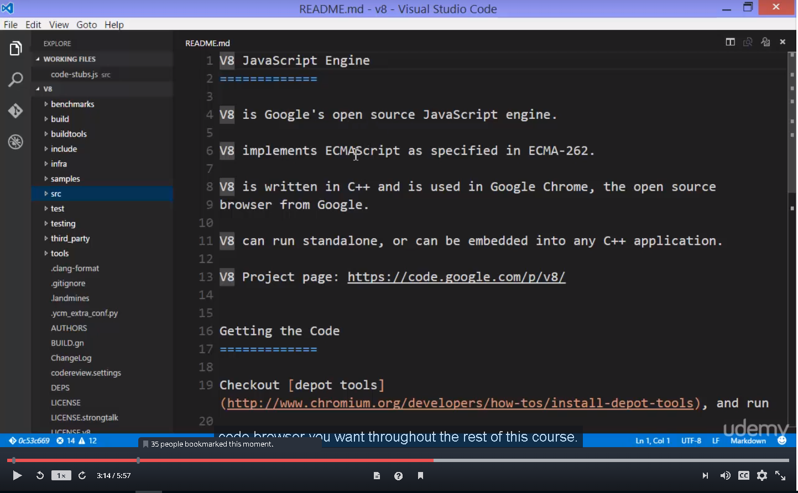

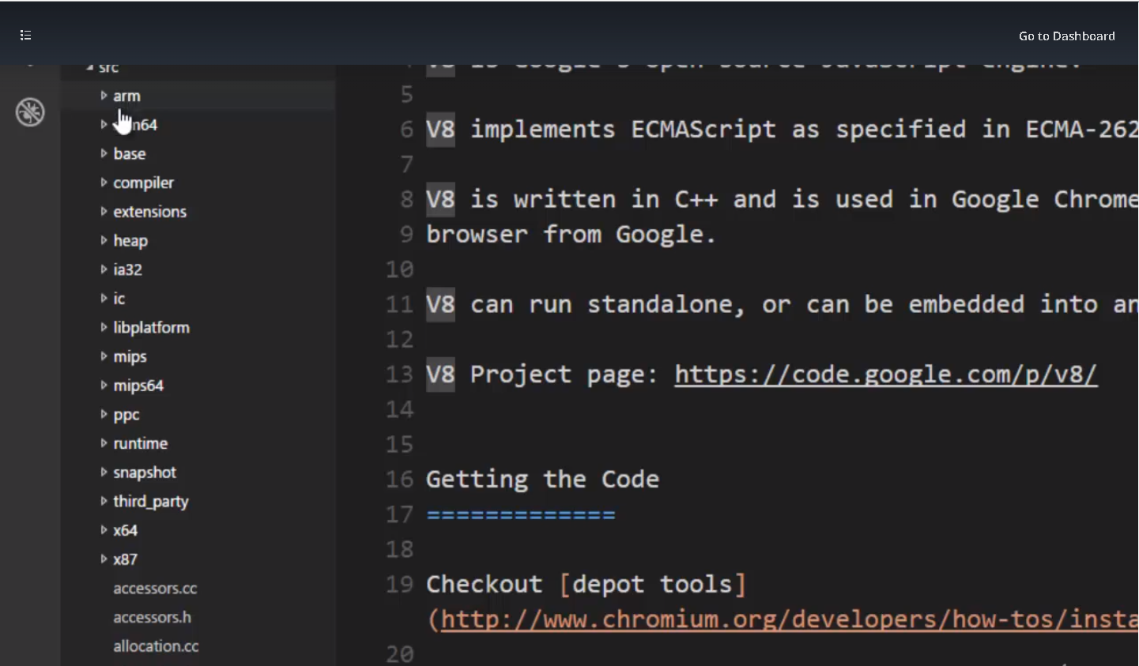

If I open this source folder, the src folder,

you already see some things that we might've seen before:

ARM,

IA32,

x64,

there's entire sets of code

for each of the machine languages that V8 supports.

So we can convert Javascript into any one of these languages

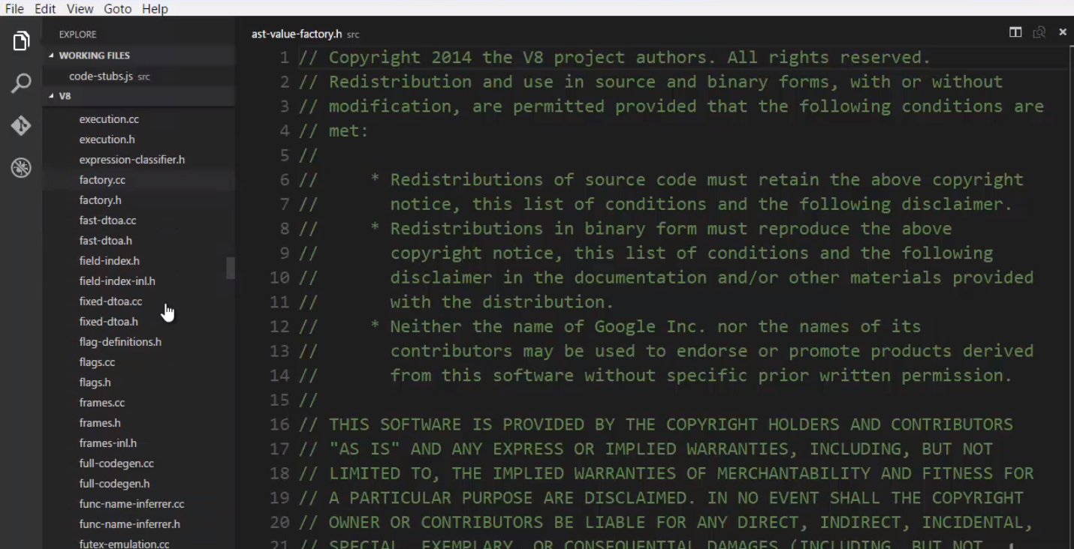

and it's more than that, inside there's a huge number

of .h and .cc files, .cc is a C++ file,

and .h is also a part of the C++ language.

All of this code, all of this C++

has to do with implementing the ECMAScript standard.

This is the engine, this is the engine's code

that will read Javascript, the text of Javascript,

and convert it into machine code,

and it's a lot of code.

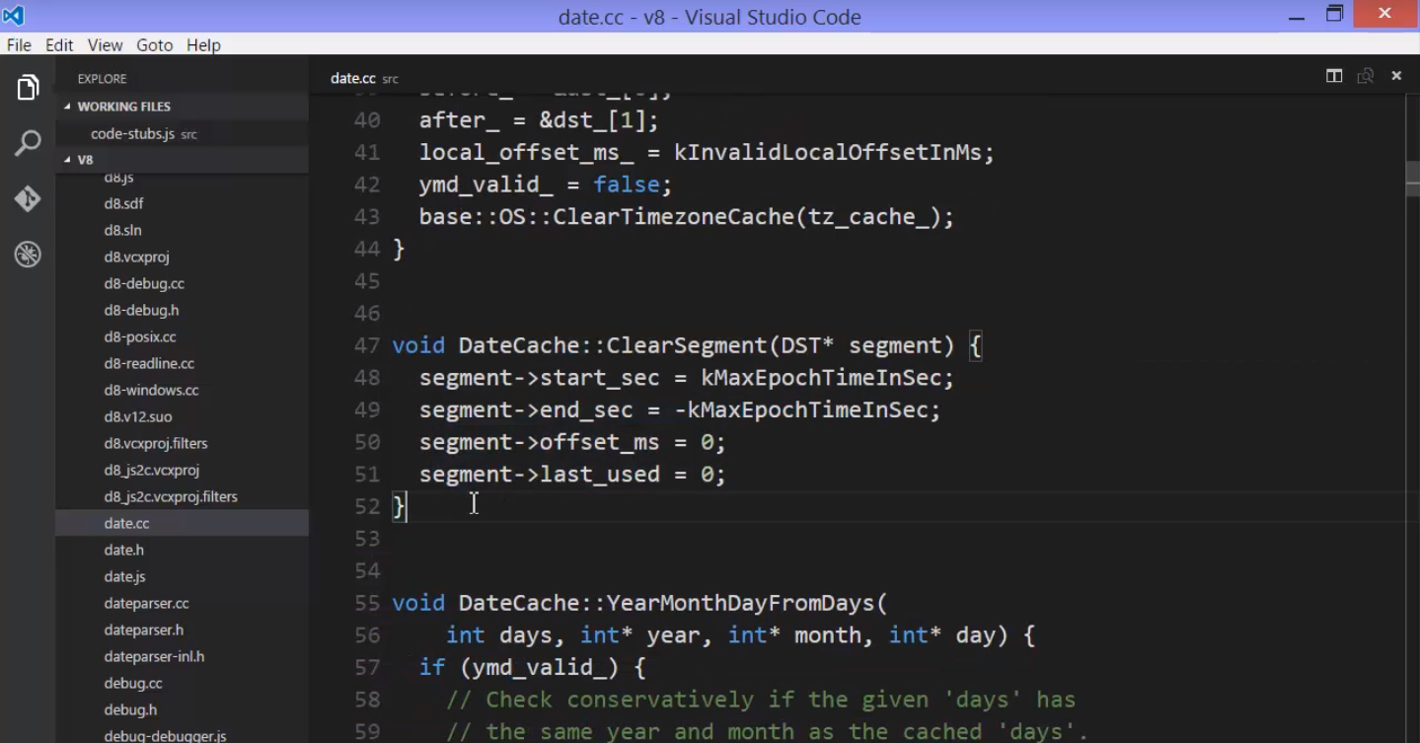

there's a date .cc file

that deals with dealing with dates.

Javascript has to deal with dates, and so there's code

written in C++, and notice this looks a little bit

like Javascript.

and this engine is gonna convert what you write

in Javascript to something that the computer processor

can actually run.

So, this is code within the engine.

V8 is huge.

It's been worked on for years, and it's highly performant,

it's really fast.

And it's extremely useful,

and it's free.

Open source, you can use it within your own programmes,

and that's what we're going to see next.

But here we can see that V8 isn't some mysterious black box.

It's just a lot of code.

Code designed to do exactly what

an engine is supposed to do, execute Javascript.

That is to say, convert Javascript code that you write,

into something far more based, far lower,

and in some ways, more complex.

# **The Node Core**

## 10. Conceptual aside – Servers and Clients

## 11.What does Javascript need to manage a server?

What are the features that we need to have accessible

in JavaScript in order to do the kinds of things

that a web server normally needs to do?

For example-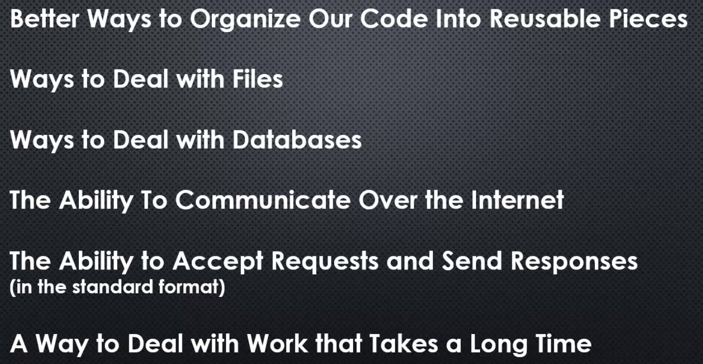

JavaScript needs better ways to organise its code

into reusable pieces.

As a developer, in other programming languages

we have better ways to do this

than JavaScript did for a long time.

Now, the new version of JavaScript ES6

actually has some better ways to do this

but Node.js was answering this question

before that existed.

We also need ways to deal with files.

If you're a web server,

you're likely going to have to work with files,

maybe zip files or images

or other things along the way.

We need ways to deal with databases.

You're almost always dealing with the database

when it comes to building web software,

and it's the web server that talks to the database.

We're a web server so we need the ability

to communicate over the internet.

JavaScript by default does not have that,

you won't find it in the ECMAScript specification.

And coming along for the ride

because we are a web server,

we need the ability to accept requests

and send responses

in the standard format that's used

in internet communication.

And also,

the web server, since it's asked to do jobs, to do work,

sometimes the things it's asked to do take a long time,

and we want people to be able to continue to access

the web server even when it's doing things

that are taking a while.

So, we need a way to deal with work

that takes a long time.

These are just some of the problems

that need to be solved when you're designing a web server,

and some of the things that JavaScript

simply doesn't have out of the box,

and these are the things,

among others,

that Node.js solves for us.

## 12.The C++ Core

--------- Document still needs to prepare , these are just few lines----------

But we can see and understand

and get a feel for the fact that there's

an awful lot of features that node.js

is adding to JavaScript, making available to JavaScript.

The mental model you should have,

is not that node.js is JavaScript,

but rather that node.js accepts JavaScript

and allows to have more features

that we write with it than normal.

## 13. The Javascript Core

## 14.Lets install and write some javascript in Node

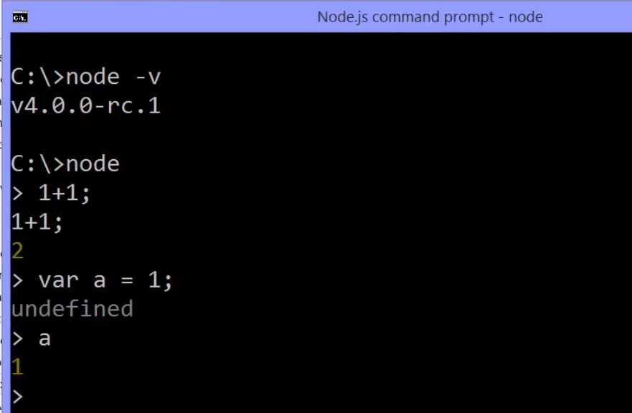

idea being that you can run the Node command

no matter what folder or file you're looking at

in the command line interface,

that Node has just become a command that you can use.

For example, in Windows you might have added Node

to your path variable, which means it's available everywhere

We're going to write some JavaScript in Node.

All you have to do is type the word Node in your computer,

in your command line interface,

That will start a command line interface programme

that comes along for the ride with Node,

where I can simply type JavaScript into the command line

and get the output back after it's been processed

through the V8 engine in Node.

So for example I can say one plus one,

and I get back the response two.

This is a lot like that little programme

that we looked at before.

**This JavaScript got passed into Node,**

**Node passed it through the embedded V8 engine,**

**as well as whatever extensions that it added**

**to the V8 engine, and we got our response back**

from that code being executed.

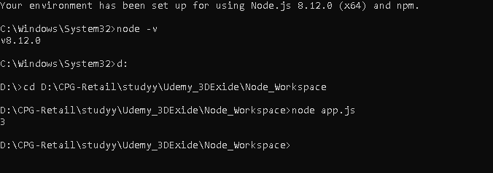

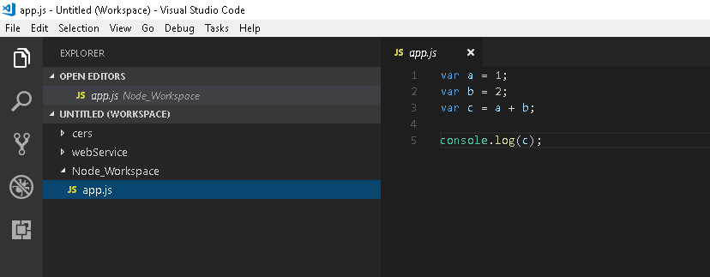

Running a js file in node.



# Modules , Export and Require

## 1.Conceptual Aside : Modules

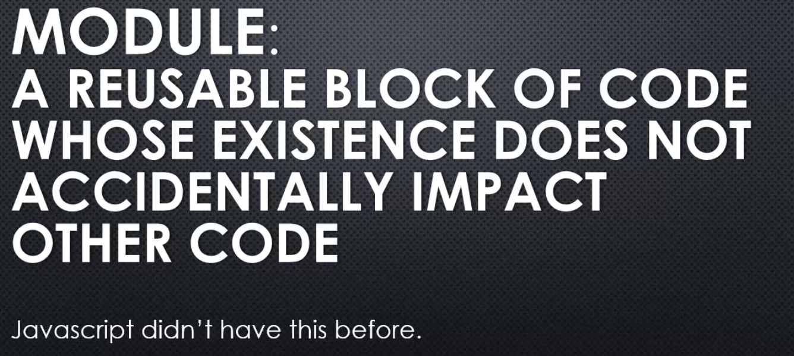

Major programming languages have this feature,

and Javascript didn't have this before.

In fact this is a new feature

for Javascript in ES 6, the latest version.

However, at the time of NodeJS's creation,

Javascript didn't have this.

It did have ways to protect your code

to be able to write your code in the module-like

format, but it was a workaround.

It wasn't an officially supported part

or aspect of the language.

So NodeJS needed to give us the ability

to build code modules, reusable blocks

where I could put code in that block of code

and it wouldn't impact other code

in the rest of my application unintentionally.

So NodeJS implements something called CommonJS modules.



You may here the phrase CommonJS.

It's just a set of standards.

So NodeJS said the way that common

JS modules, the way that standard

says the way modules should be structured,

we agree with that.

So we're going to design a way for you to structure

your Javascript code in modules that

will follow this standard.

## 17

Remaining for documentation



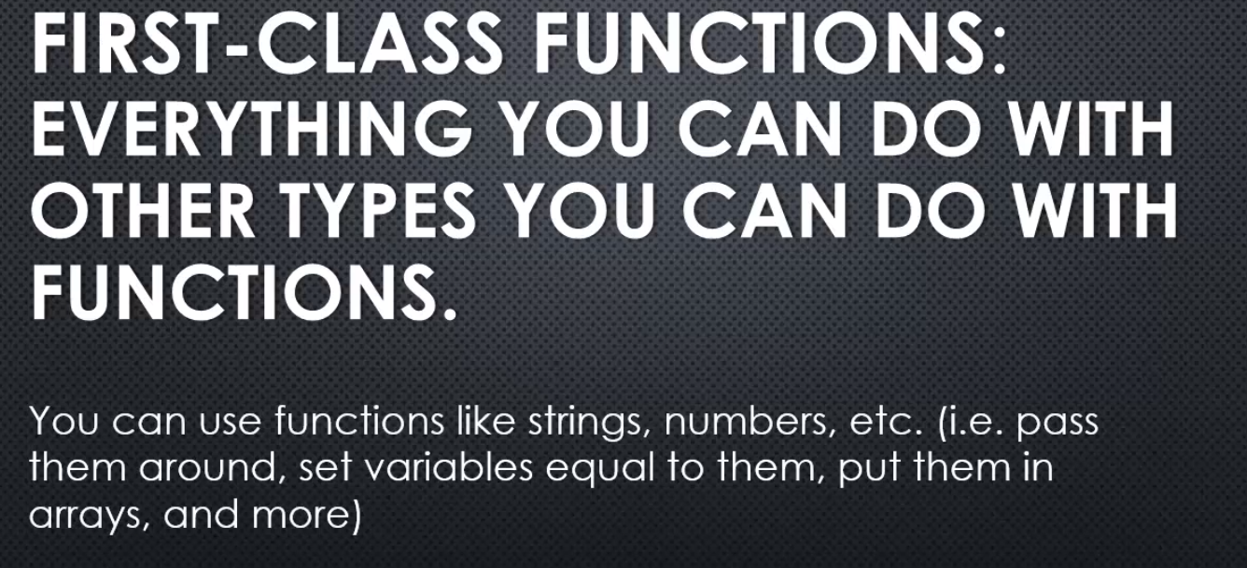





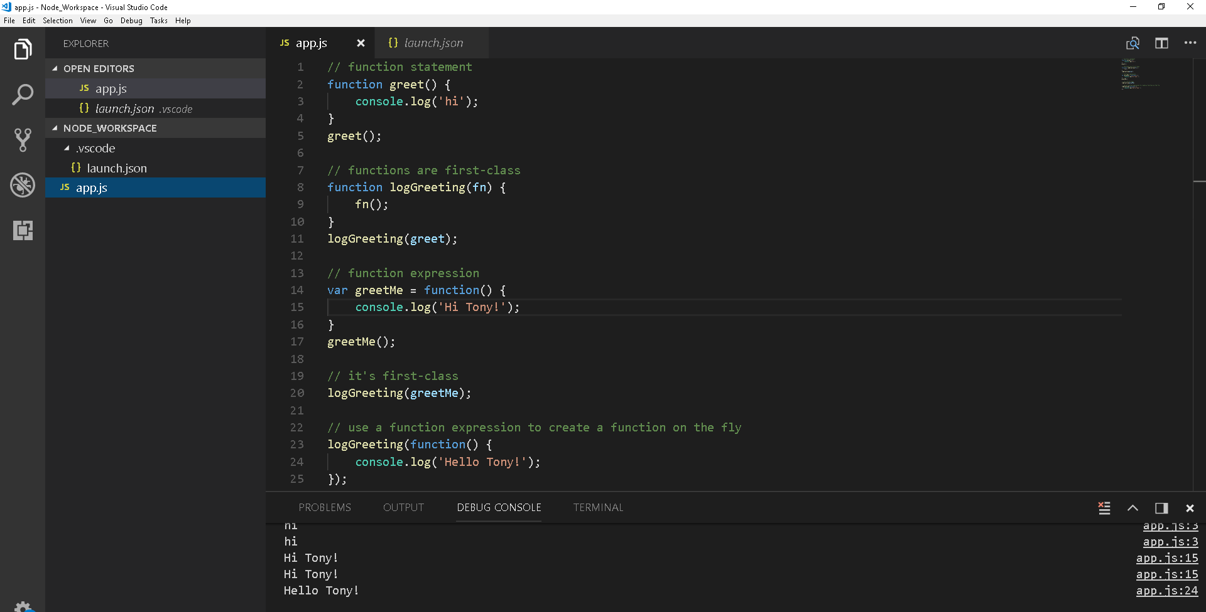

## 18.Let’s Build a module

Remaining to be documented

